**Project Title:** AI-Powered Content Calendar Scheduler Bot

**Brief Description:** Developed an AI-driven Content Calendar Scheduler Bot designed to streamline content planning and scheduling. This bot leverages OpenAI's ChatGPT to generate a continuous stream of topic ideas and seamlessly integrates them with various content types. The solution automates the creation of a strategic content calendar, ensuring that future initiatives are well-organized and aligned with overall content strategy.

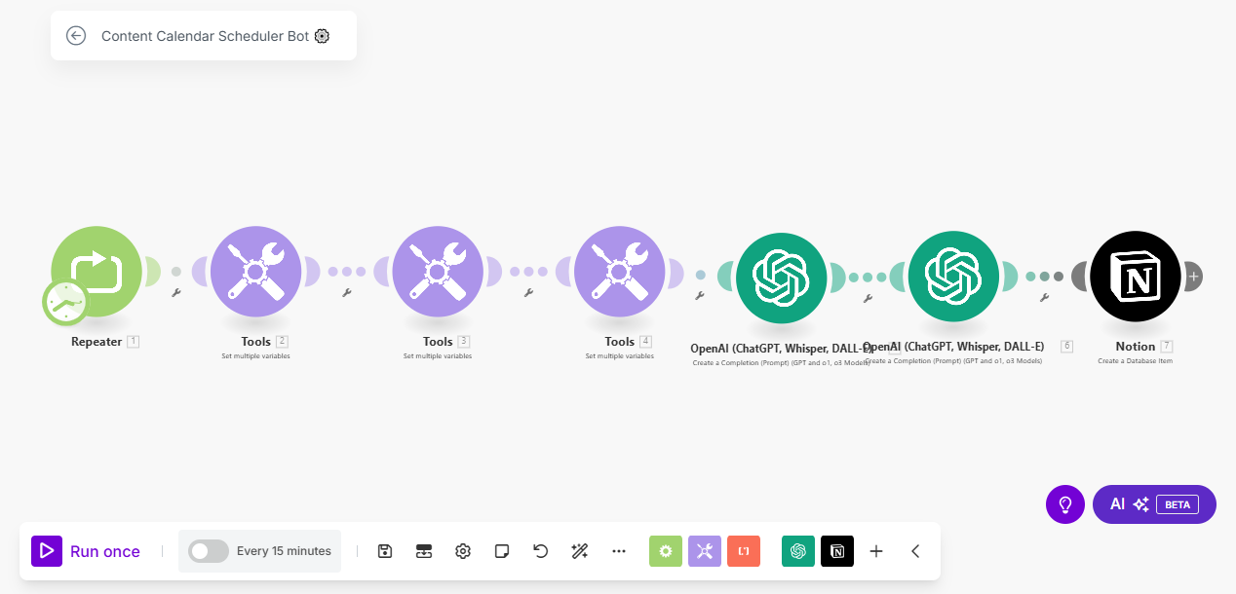

**Skills Used:** AI content generation, content strategy planning, automation, and workflow optimization using Make.com. The bot integrates OpenAI's ChatGPT for intelligent topic generation and Notion for database management and scheduling.

**Relevant Outcomes/Achievements:** Successfully implemented a zero-coding, plug-and-play solution that runs on autopilot, making it accessible for users without technical expertise. The bot's ability to generate and schedule content ideas every 15 minutes ensures a consistent and strategic content pipeline. This project has enabled users to enhance their content planning processes, leading to more organized and effective content strategies. The fully customizable nature of the bot allows users to tailor content generation and scheduling to specific needs, ensuring relevance and impact.

**Key Features:**

* Automated generation of content topic ideas using AI.
* Seamless integration with Notion for database management and scheduling.
* Fully customizable and adjustable to meet specific content planning requirements.
* Zero coding required, ensuring ease of use for non-technical users.